Paul Polsinelli

IFT 410 - 22485

1/13/2021

Module 1 Lab: Python Scripting

1. import pandas as pd

#create a file handle

Log = open('user_access.log', "r")

#iterate over and print all lines

for line in Log: print(line)

Log.close()

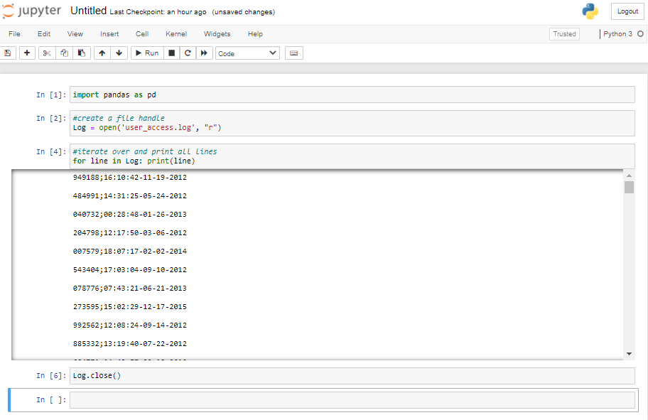

1. import pandas as pd

#create a file handle

Names= open('names.txt', "r")

#iterate over, strip spaces, split string, and print

for line in Names:

line = line.strip()

FName = line.split()

print(FName[0])

Names.close()        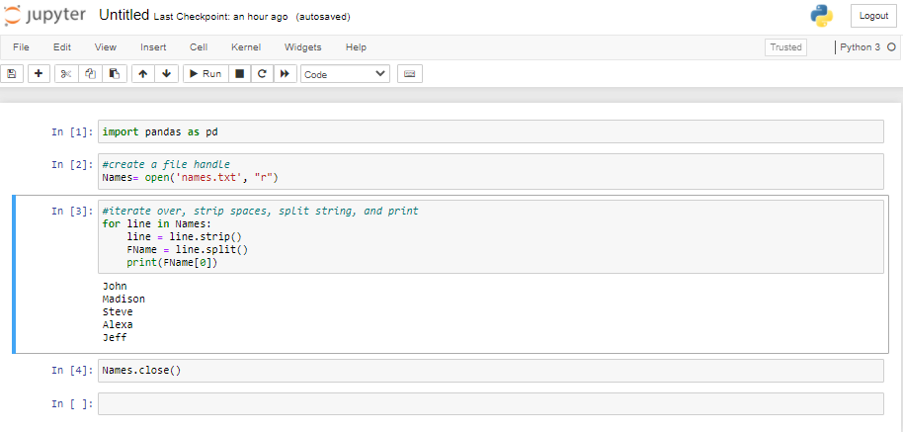

1. import pandas as pd

#create a file handle

Names= open('names.txt', "r")

# set total and count

total = 0

count = 0

#iterate over, strip spaces, split string, define age, compute total, and iterate count

for line in Names:

line = line.strip()

FName = line.split()

age = int(FName[-1])

total = total + age

count = count + 1

# compute avg and print

avg = total/count

print(avg)

Names.close()

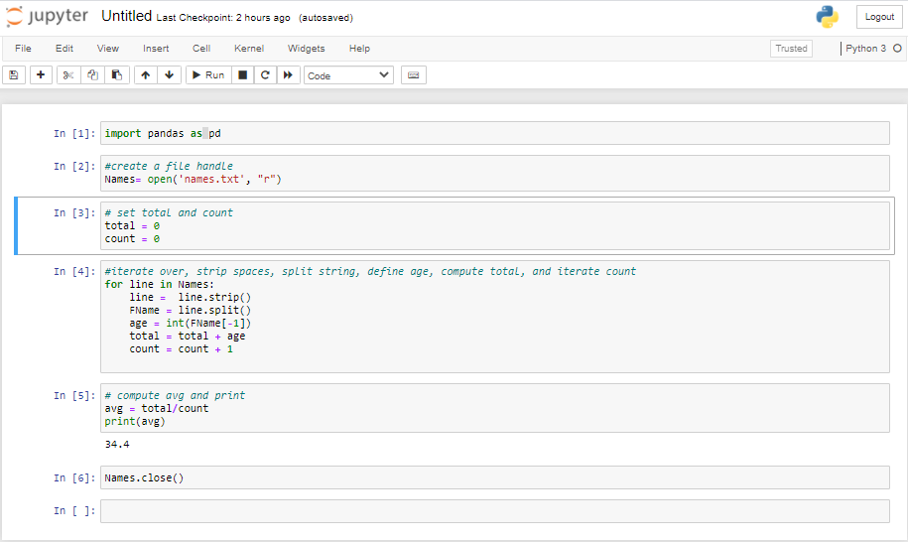

1. import pandas as pd

#create a file handle

Log = open('user_access.log', "r")

#create dictionary

user_access = {}

#iterate over, split string on semicolon, strip, and store user ID and access time

for line in Log:

user_id, time = line.split(';')

user_access[user_id.strip()] = time.strip()

Log.close()

print('Last access time for user ID 000397:', user_access['000397'])

print('Last access time for user ID 126052:', user_access['126052'])

